1. Derive the relation between Q-factor, BW and resonance frequency of a series resonating circuit.
2. State and explain Thevenin’s theorem and Superposition theorem.
3. State Kirchhof’s Current Law. Find the magnitude and direction of the unknown currents in fig.2. Given $i_{1}=10 A, i_{2}=6 A, i_{5}=4 A.$
4. From the given network in fig. 3, draw its graph. Select a suitable tree and obtain the tie-set and cut-set matrix.

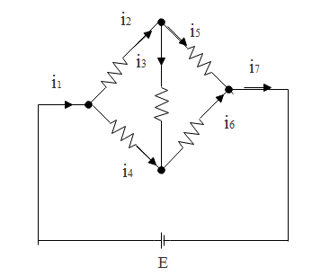  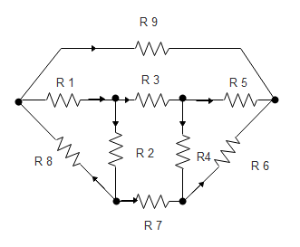

*fig.2 fig. 3*

*************************************************

**SCHOOL OF ENGINEERING AND TECHNOLOGY**

D.C. COURT JUNCTION, DIMAPUR

**END TERM EXAMINATION JUNE 2017**

|  |  |  |  |  |  |
| --- | --- | --- | --- | --- | --- |
| **Course Code:** | EC3T01 | **Semester:** | III | **TotalMarks** | 60 |
| **Course Name:** | **Network Theory (BP)** | | | **Time:** | 3hrs. |

**Answer the following questions.**

1. **Choose the correct answer. (10x1=10)**
2. In a cut set graph, number of branches are B=4, number of nodes are N=3. Number of links will be
3. 4 (b) 3 (c) 2 (d) 1
4. In an ac circuit, the current
5. is always in-phase with the emf
6. always leads the emf
7. always lags the emf
8. any of the above, depending upon the elements of the circuit
9. An inductor stores energy in
10. electrostatic field
11. magnetic field
12. electromagnetic field
13. none of above
14. A terminal where three or more branches meet is known as
15. branch b) node c) loop d) circuit
16. The current through an inductance follows
17. a linear growth
18. a linear decay
19. an exponential decay
20. an exponential growth
21. At t=0+ with zero initial condition, which of the following act as open circuit?
22. inductor b) capacitor c) resistor d) all of the above
23. The superposition theorem is applicable to
24. current only
25. voltage only
26. both current and voltage
27. current, voltage and power
28. A capacitor is …….element
29. passive and bilateral
30. passive and unilateral
31. active and bilateral
32. active and unilateral
33. At resonance, in series LCR circuit, which relation is not valid
34. $ω=\frac{1}{LC}$ (b) $ω=\frac{1}{\sqrt{LC}}$ (c) $Lω=\frac{1}{ωC}$ (d) $ω=\frac{1}{ωL}$
35. Kirchhoff’s law is applicable to
36. ac circuits only c) ac as well as dc circuits
37. dc circuits only d) passive network only
38. **Answer any five questions. (5x4=20)**
39. What are the properties of tree in a graph? Give the relation between twigs and links.
40. Define the following network graph theory terms

branch; tree link; degree of node; tie-set.

1. What are the steps involve for solving a network using Norton theorem.
2. Give the properties of resonance of RLC series and parallel circuit.
3. A coil having an inductance and resistance of 50 mH and 100 ohms is connected in series with a capacitor and a 100 V, 1 kHz source. Calculate the value of capacitance that will cause resonance in the circuit and the circuit current at resonance frequency.
4. Write short note on resonance in electrical circuit and transient response of passive circuit.
5. **Answer any four questions. (4x7.5=30)**
6. A 220 V, 100 Hz ac source supplies a series LCR circuit with a capacitor and a coil. If the coil has 50 mΩ resistance and 5 mH inductance, find, at a resonance frequency of 100 Hz what is the value of capacitor? Also calculate the Q factor and half power frequencies of the circuit.
7. Develop nodal equation in nodes (1), (2) and (3) in the circuit given in fig.1

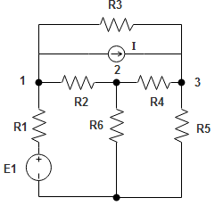*fig.1*