** SCHOOL OF ENGINEERING AND TECHNOLOGY**

D.C. COURT JUNCTION, DIMAPUR

**End Term Examination Dec. 2016**

|  |  |  |  |  |  |
| --- | --- | --- | --- | --- | --- |
| **Course Code:** | EC4T01 | **Semester:** | IV | **Total Marks** | 60 |
| **Course Name:** | **Control Engineering (BP)** | | | **Time:** | 3 hr. |

**Answer the following questions.**

1. **I. Choose the correct answer (1x5=5)**
2. The transient response of a system is mainly due to
3. internal forces (b) stored energy (c) friction (d) inertia forces
4. The main application of transfer function is in the study of
5. steady behaviour of system (c) steady as well as transient behaviours of system
6. only transient behaviours of system (d) neither transient nor steady behaviours of system
7. A good control system has all the following features except
8. good stability (b) slow response (c) good accuracy (d) sufficient power handling capacity
9. The transient response, with feedback system
10. rises slowly (b) rises quickly (c) decays slowly (d) decays quickly
11. A control system in which the control action is somehow dependent on the output is known as
12. Closed loop system (b) semi-closed loop system (c) open loop system (d) none

**II**. **True/false (1x5=5)**

1. The steady state error for type 1 system is zero.
2. In an unstable system, it is possible to achieve initial equilibrium.
3. In signal flow graph a path which originate and terminates on the same node is known as feedback path.
4. The transfer function equation determines the system dynamics.
5. Nyquist criteria gives direct value of corner frequency.
6. **Answer any five questions. (5x4=20)**
7. Define open loop and closed loop system? List out the difference between open loop and closed loop system.
8. Write a short note on transfer function of a control system? Define poles and zeros of a transfer function.
9. What is a transfer matrix? Show that transfer matrix is $G\left(s\right)=C{(sI-A)}^{-1}B+D$
10. Define the following transient response specification of second order control system.

Rise time; maximum overshoot; peak time; settling time; damping ratio.

1. What is steady state error? Explain the types of static error coefficient.
2. Using Routh criterion determine the stability of the system having the characteristics equation as
$$s^{5}+{1.5s}^{4}+{2s}^{3}+{4s}^{2}+5s+10=0$$

3. Determine the overall transmittance from the signal flow graph. Apply Mason’s gain formula.

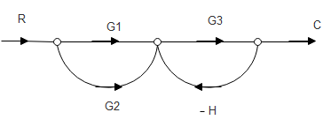fig.1

1. **Answer any four questions. (4x7.5=30)**
2. Write in stepwise the procedure for plotting the root locus for a given open loop transfer function.
3. Reduce the block diagram into

(i) a form having one block in the forward path and one in feedback path

(ii) determine the overall transfer function

(iii) single block representation form

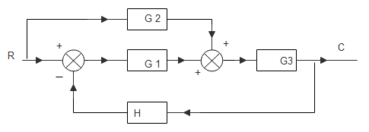fig.2

1. What is transient response and steady state response? Discuss types of input test signals applied for time response analysis of a control system.
2. The characteristics equation of the system is given: $s^{2}+6s+25=0$

Find the value of $ω_{n}$, damping ratio, $ω_{d}$, $t_{p}{,M}_{P},$ the time at which the first overshoot occurs and the period of oscillation.

1. The closed loop transfer function of a unity feedback control system is given below.

Determine the steady state error for unit ramp input and also find the value of $K_{p} and K_{a}$.

$\frac{C(s)}{R(s)}= \frac{Ks+ β}{s^{2}+ αs+ β}$

##########################################################################